APP-BASED DIGITAL AUDIOMETER

ABSTRACT:

This study introduces a novel app-based digital audiometer designed for the modern era, offering a portable, cost-effective solution to assess an individual's hearing capabilities. Leveraging the ubiquity of smartphones and web applications, the system utilizes compatible hardware to conduct comprehensive hearing tests, enhancing accessibility across diverse user demographics and settings. The primary testing modality, Pure Tone Audiometry, evaluates the user's ability to perceive pure tones at various frequencies. Users respond to audible tones by pressing a button within the application interface. The collected data is meticulously analyzed to generate a detailed hearing profile, providing insights into the user's hearing thresholds across different frequencies. Upon completion of the hearing test, the app presents the user with a comprehensive hearing profile. This profile clearly depicts any identified hearing loss, aiding users in understanding their auditory health. Additionally, the application may offer valuable recommendations, such as encouraging further evaluation by a professional audiologist when necessary. The app-based digital audiometer stands out as an innovative, user-friendly tool for hearing assessment, fostering a broader reach and increased convenience for individuals seeking to monitor their auditory well-being. This research underscores the potential of combining smartphone technology with advanced audiometric capabilities, contributing to the evolution of portable and accessible healthcare solutions.

USE CASE:

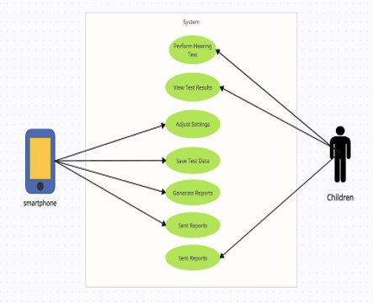

**DESCRIBE THE TECHNOLOGY STACK:**

**1. Setting Up Development Environment**:

Choose appropriate development tools, frameworks, and libraries. Integrate Full Stack Technologies for seamless communication between the front-end and back-end components. Establish database connections and ensure server-side readiness.

**2. Design User-Friendly UI/UX and User Guide:**

Create an intuitive and visually appealing user interface for the app. Implement user-friendly navigation to ensure a smooth experience. Develop a comprehensive user guide to assist users in understanding the app's functionalities and navigation.

**3. Authentication and User Management:**

Implement secure authentication mechanisms, such as OAuth or JWT, to safeguard user data. Develop a user management system to handle user registration, profile creation, and account settings. Ensure data privacy and security throughout the authentication process.

**4. Hearing Test Module: Pure Tone Audiometry:**

Integrate the Pure Tone Audiometry module, allowing users to undergo hearing tests. Implement an interactive interface for users to respond to pure tones at different frequencies. Ensure real-time data recording during the hearing test process.

**5. Data Collection and Analysis:**

Develop mechanisms to collect and store user data securely. Implement algorithms for the analysis of collected data to generate accurate hearing profiles. Integrate visualization tools to present the analyzed data in an understandable format.

**6. Accessibility, Testing, and Quality:**

Ensure the app adheres to accessibility standards for users with disabilities. Conduct thorough testing, including unit testing, integration testing, and user acceptance testing. Implement quality assurance practices to identify and rectify bugs or issues.

**7. Results and Reports Generation:**

Develop a results module that presents the user with a detailed hearing profile. Include features for generating comprehensive reports based on the test results. Provide clear recommendations and information about identified hearing loss.

**Conclusion:**

This hybrid app, developed using Full Stack Technologies and Android Studio, offers a comprehensive solution for digital audiometry. The emphasis on a user-friendly interface, robust authentication, accurate testing modules, and detailed results and reports ensures a holistic approach to hearing assessment. The app not only prioritizes the user experience but also adheres to the highest standards of data security and analysis, making it a valuable tool in the field of digital healthcare.